Population Child Health PhD Scholarship
Applications are being sought for a new PhD scholar to join the Population Child Health Clinical Research Group at UNSW Sydney.
Applications will only be accepted as a Microsoft Word Document submitted by email.
Please send to Samantha McFedries by midnight on 18th September 2020.
Before completing this form, ensure you have read the Paediatric Population Health PhD Scholarship Guidelines, below.

Population Child Health Clinical Research Group
UNSW Medicine is a national leader in learning, teaching and research, with close affiliations to Australia’s finest hospitals, research institutes and health care organisations. With a strong presence at UNSW Kensington campus, the faculty have staff and students in teaching hospitals in Sydney as well as regional and rural areas of NSW including Albury/Wodonga, Wagga Wagga, Coffs Harbour and Port Macquarie.
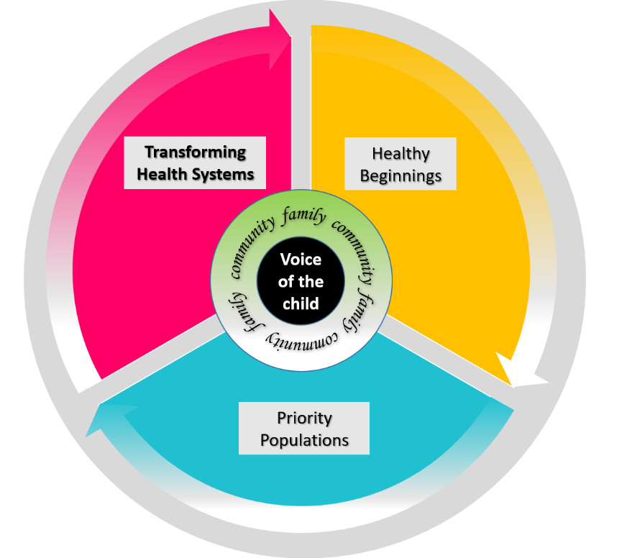
The School of Women’s & Children’s Health (SWCH) is comprised of the clinical disciplines of Obstetrics & Gynaecology and Paediatrics, and the National Perinatal Epidemiology Statistics Unit (NPESU). Clinical academics in the School are located at the Royal Hospital for Women, Sydney Children’s Hospital, St George and Bankstown Hospitals, with teaching contributions made in Paediatrics at the Sutherland, Liverpool and Campbelltown Hospitals. The main administrative centre for the School is based at the Royal Hospital for Women and Sydney Children’s Hospital, Randwick.
Population Child Health
Clinical Research Group Themes
The PhD candidate will work within the Population Child Health Clinical Research Group, UNSW. The Population Child Health Clinical Research Group is an integrated multidisciplinary translational research team working across the Sydney Children’s Hospital’s Network and South West Sydney Local Health District. We work with partners in Local Health Districts, State and Commonwealth governments, to inform service delivery and policy through innovation, collaboration, research, policy development and advocacy.

Guidelines for Applicants
The Population Child Health Clinical Research Group will award a scholarship to student of excellent research potential, enabling them to undertake a PhD within the Heath Systems research stream, on a NHMRC partnership grant: Strengthening Care for Children (SC4C): A stepped-wedge translational trial to reduce hospital burden.
SC4C is a stepped-wedge trial of a specialist paediatric integrated care intervention that aims to strengthen GP quality of care for children and young people (<18 years) and reduce GP referrals to hospital outpatient clinics (OP) and emergency departments (ED).
PhD topics available to be nested within the SC4C trial.
- Exploring the concept of trust between practitioners, parents, and young people, using a mixed methods approach; or
- Exploring the concept of value-based medicine in primary care.
Stipend:
The scholarship will provide financial support to assist the student with living costs in the form of a stipend. It will have a value of $20,000 per annum, payable for three years. The scholarship will be paid fortnightly as a stipend by the Graduate Research School (GRS).
Tuition Fees:
This scholarship does not cover tuition fees. Applicants are encouraged to apply for a Domestic or International Research Scholarship from UNSW Sydney or other source.
Duration:
This scholarship is provided for three years at a rate of $20,000 per annum. Applicants are unable to defer the offer of scholarship. Only full-time candidates are eligible to apply.
Supervisors:
The student will be jointly supervised by Prof Raghu Lingam and Dr Jade Burley in the School of Women’s & Children’s Health, UNSW Sydney with additional support from Prof Teng Liaw and Prof Harriet Hiscock.
Applicant:
Students from all backgrounds (allied health, nursing, medical, and basic science) are eligible to apply, provided they meet the academic requirements of UNSW Sydney. Applications will be accepted from both domestic and international candidates.
Conditions:
At the time of the scholarship application, the candidate must have applied for admission to the PhD programme at UNSW Sydney. The scholarship funding will not be released until the application for admission has been accepted, and the candidate has enrolled.
The recipient of the scholarship (upon acceptance of the award), will be required to provide:
- A photograph for publicity and fundraising use; and
- A lay summary describing the project aims, methodology, and expected outcomes for the School of Women’s & Children’s Health and Population Health Research Group to use in the funding announcement and in other promotional material.
The project must receive human research ethics and if applicable, site-specific research governance approval.
The recipient of the scholarship will be required to provide annual report to the School of Women’s & Children’s Health detailing the progress of the research and any impact.
It will be expected that the recipient will present regularly at appropriate research meetings throughout their candidature.

PERSONAL DETAILS:
Name:
Email:
Current employer / University
Position / Degree:
CV:
Qualifications, Awards & Prizes:
Employment History:
Career Disruption:
Professional Memberships:
Conference Presentations:
Community Engagement & Participation:
Supervision & Mentoring:
Research Funding:
Publications:
ACADEMIC PERFORMANCE:
Outline your academic performance.
This is opportunity to draw attention to highlights of your academic performance, or to emphasise aspects of your choice of subject.
Word Limit: 250 words
Please attach a copy of your academic transcript.
PREVIOUS EXPERIENCE:
Provide brief details of your previous experience highlighting the most significant contributions you have made to your field of research.
Word Limit: 250 words
Provide brief details from your previous experience that most significantly affects your research proposal.
Word Limit: 250 words
CAREER ASPIRATIONS:
Describe how this scholarship would contribute to your future career aspirations.
Word Limit: 250 words
Highlight how the research topic relates to your current and future professional pathway.
Word Limit: 250 words

RESEARCH PROPOSAL (no more than 5 pages):
Please provide a brief research plan (maximum five A4 pages, including references) detailing the following:
  - Aims
  - Background
  - Methodology
  - Significance of the proposal
  - References
The proposal must not exceed five A4 pages (including references). Please use Arial 10pt font, and do not adjust the margins.

